Unit 2 Image Analysis and KEY
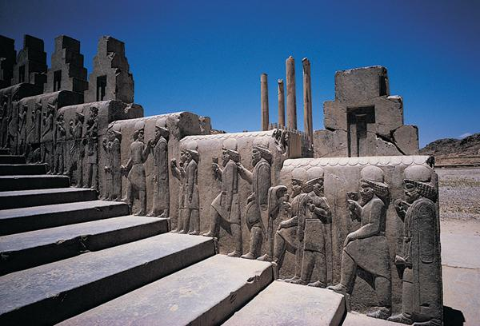
1. Looking at the image above, what can be deduced about Persian aristocrats?
Your answer should include the following:
• The image shows a carving of Persian nobles ascending the stairs of the imperial palace at Persepolis.
• The image suggests that the Persian aristocracy was fairly large during the imperial era.
• It also reveals the predominant dress and hairstyles of the era, consisting of long flowing robes, fine circular hats, and braided hair and beards.
• The image also suggests that nobles regularly attended the imperial palace on both official and non-official purposes.

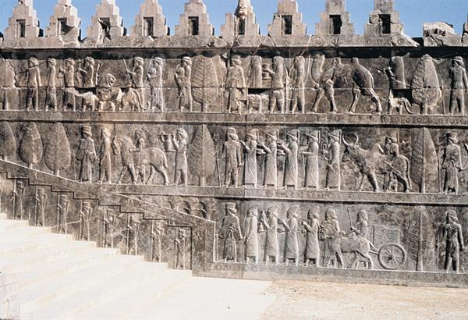
2. Using the image and the text, discuss the wealth and power of Achaemenid civilization.
Your answer should include the following:
• As the image suggests, the Achaemenid emperors ruled over an enormous empire that connected the
Mediterranean world with Mesopotamia, Persia, and India.
• This vast region was enormously wealthy, providing a huge range of goods and services.
• Access to and control of this wealth, and the agricultural and trade networks that provided it, made the
Achaemenid emperors as powerful as any ruler on the planet in their era.
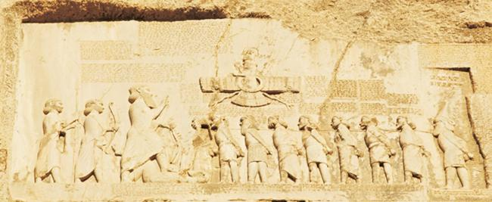
3. Looking at the image, what does it suggest about the influence of Zoroastrianism during the reign of Darius?
Your answer should include the following:
• The image shows Darius facing Ahura Mazda and raising his hand toward the deity in acknowledgment
of Ahura Mazda's superiority.
• The presence of the various subordinate monarchs in the carving also suggests an explicit argument
concerning the cosmic order: first the deity, then the emperor, then the subordinate kings.
• The different sizes and locations of the monarchs also reinforce the message about cosmic order.
• The image suggests that Zoroastrianism enjoyed considerable influence in the Achaemenid empire
during Darius's rule

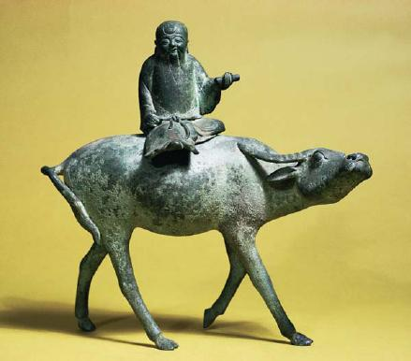
4. Looking at the image, what does it tell us about Laozi and his teachings?
Your answer should include the following:
• The jade statue of Laozi riding on an ox reconstructs the sage's journey from China to central Asia,
which he purportedly took while riding a blue ox.
• It embodies several Daoist principles, including ideas of living simply and in harmony with nature.
• It also embodies suggestions of simplicity and self-sufficiency, and the development of a reflective
consciousness.

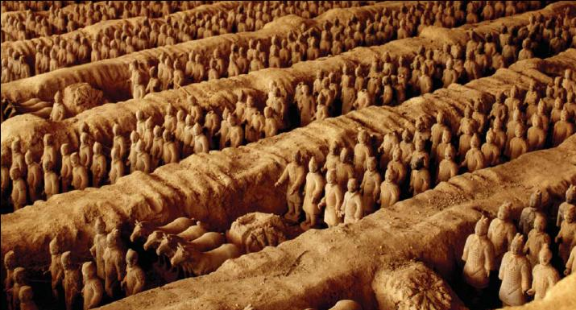
5. Look at the image above, and identify features that indicate what type of society existed during the reign of Qin Shihuangdi.

Your answer should include the following:
• As the image shows, the tomb of Qin Shihuangdi contains thousands of life-size terra-cotta soldiers.
• These soldiers are arranged in military formations and clothed in full armor with weapons.
• There are also horses, carts, and equipment.
• The buried army suggests that the society of the First Emperor was highly militarized and that he
commanded enormous military forces.
• It also suggests that the First Emperor possessed unrivalled power and control over his subjects.

6. Looking at the image and the text, what does his tomb suggest about Qin Shihuangdi's power and ability to command resources?

Your answer should include the following:
• The image suggests that Qin Shihuangdi possessed huge amounts of power and access to resources.
• The very scale and complexity of the terra-cotta army indicates that, even in death, the First Emperor
possessed absolute authority.
• The lavish tomb was constructed by over seven hundred thousand drafted laborers and contained rare
and expensive grave goods, along with sacrificed concubines and slaves.

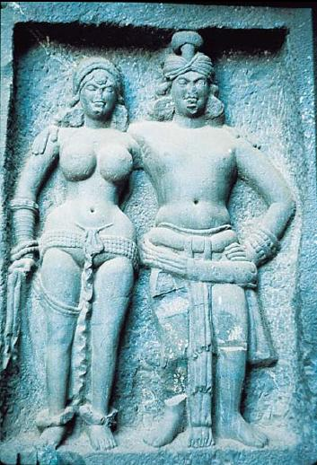
7. Looking at this image, what does it suggest about the Buddhist approach to social relationships?
Your answer should include the following:
• Buddhist art often sought to depict individuals as models of social relationships.
• Buddhist doctrine also emphasized the importance of simplicity, self-control, and harmony.
• The couple is depicted as healthy, physically fit, and content with themselves and each other.
• These dispositions, Buddhists argued, should be goals achieved through the Four Noble Truths and the Noble
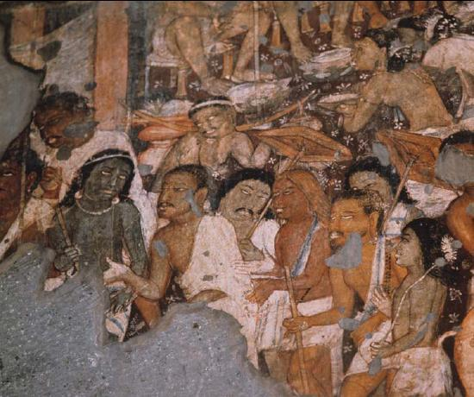
8. Looking at the image above, what does it suggest about the relationships between caste, or jati, and skin color?
Your answer should include the following:
• The image suggests a clear relationship between the development of caste identity based on ethnicity
and skin color.
• The word caste is derived from the Portuguese casta, which means "color."
• Early Aryan texts refer to differences between themselves and the darker-skinned Dravidians as a
source of caste separation.
• Long after intermingling of the two groups rendered such perspectives irrelevant, these perceived
differences exerted influence within the expanding caste system.
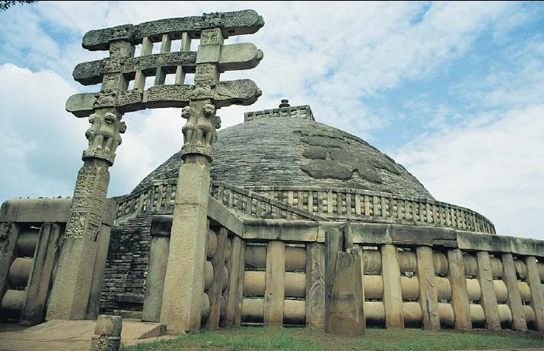
9. Looking at the image above, identify important aspects of the structure's design that reflect Buddhist views of the universe.

Your answer should include the following:
• The Buddhist Stupa at Sanchi contains several integrated design elements that reflect Buddhist conceptions of the universe.
• The structure is a domed shrine, representing the dome of heaven over earth, intended to contains sacred relics of the Buddha.
• Atop the dome is a square railing with a spire holding three parasols.
• The various shrine components symbolize five elements: earth, wind, fire, air/wind, and space.
• The shrine is flanked by four entry gateways carved with scenes from the Buddha's life.
• The southern gateway in the image contains carvings of four lions, a Buddhist symbol associated with strength and power.

10. Look at the image above, and explain what it suggests about the role of trade in Minoan society.
Your answer should include the following:
• As the image shows, maritime trade was enormously important for Minoan society.
• Crete's location between the Aegean Sea and the eastern Mediterranean made it a likely focal point for
ancient maritime trade across the region.
• The beauty and complexity of the image also suggests Minoan society was extremely wealthy, and that
these benefits derived primarily from trade.

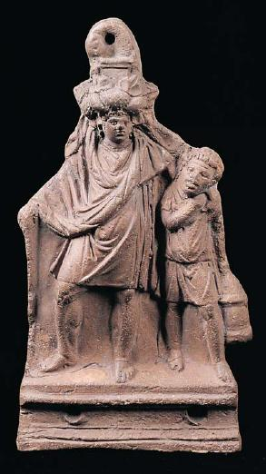
11. Looking at the image, explain what it tells us about slavery in classical Greece.
Your answer should include the following:
• The image shows a slave with a lantern, guiding his drunken master home after a party.
• It indicates that slaves were used for domestic duties in classical Greece.
• It also suggests that slaves and master often formed close bonds.

12. Using the image and the text, discuss the roles and duties of slaves in classical Greek society.
Your answer should include the following:
• Slavery was a common form of labor mobilization in classical Greece.
• Slaves consisted of formerly free Greeks who found themselves unable to pay debts, soldiers captured
in war, or foreigners sold at slave markets throughout the Greek world.
• Slaves were assigned tasks according to their physical attributes and education.
• Large, powerful slaves performed heavy labor, while smaller slaves often served in domestic roles, such as that of the slave pictured in the image above.
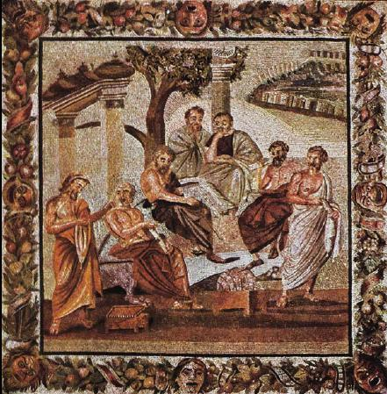
13. Look at the image of Plato and his students. What does it suggest about the connections between philosophical knowledge and civilization?

Your answer should include the following:
• The image shows Plato discussing philosophical issues with his students.
• They are all listening closely, standing at ease or reclining in chairs in contemplative poses.
• Surrounding the men are architectural columns, suggesting a complementary connection between the
generation of knowledge and advanced civilization.
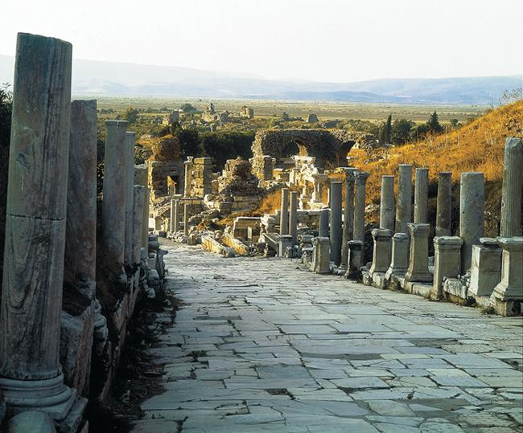

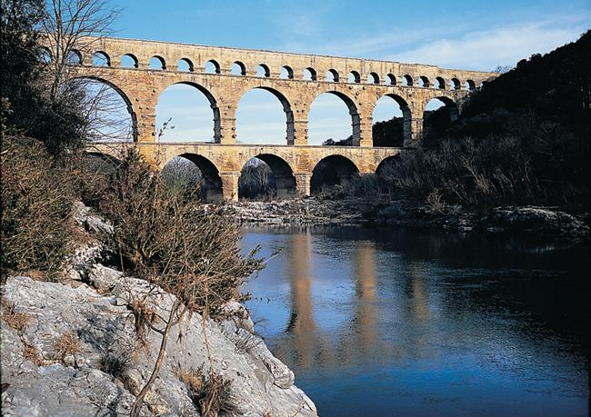

14. Using the images and the text, discuss the important achievements of Roman engineering and applied architecture.

Your answer should include the following:
• The Romans developed extremely advanced engineering and architectural systems such as the
aqueduct shown in the image.
• These systems were so well designed and built that many still work today.
• Roman roads were another example of these advanced methods, as were the enormous circuses,
stadiums, and amphitheaters like the Circus Maximus, which could hold 250,000 visitors.
• The Colosseum in Rome, whose ruins still stand, is another example of these techniques, as it could be
flooded with water to stage naval battles.

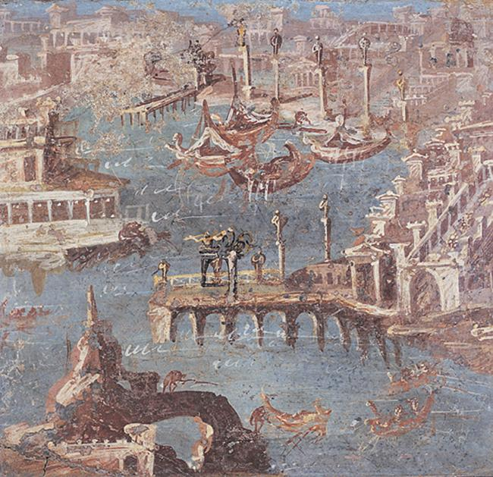

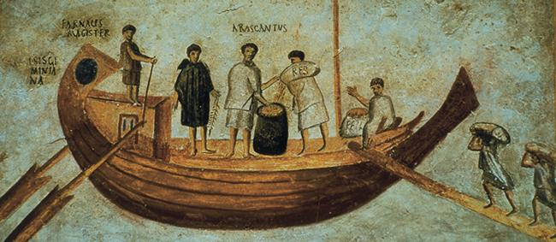
15. Using the images and the text, discuss the importance of trade for the Roman economy.
Your answer should include the following:
• As the Romans expanded across the Mediterranean, they facilitated the expansion of maritime trade
throughout the region.
• Roman military and naval power kept the seas largely free of pirates, and this encouraged both an
increase in naval trade and the carrying of larger cargoes.
• The paintings show that Roman society generated enormous volumes of maritime trade and that this
trade resulted in considerable economic growth and wealth creation.
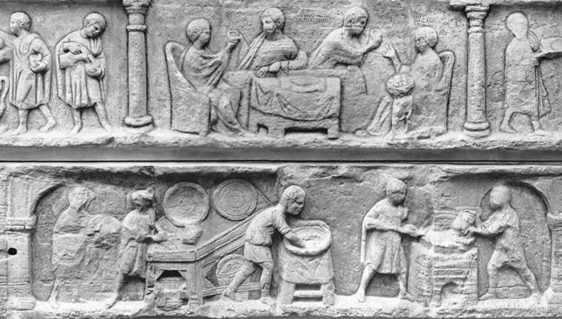
16. Using the image and the text, discuss the circumstances of slaves in the cities during the classical Roman era.

Your answer should include the following:
• For slaves working in the cities, conditions were generally much more favorable than in the countryside.
• Female slaves commonly worked as domestic servants, while males also performed these tasks in
addition to serving as laborers, craftsmen, shopkeepers, or business agents.
• As the image above suggests, the large number of slaves employed as domestic servants meant that
labor demands could be shared among a group, rather than being the responsibility of one slave.

`1
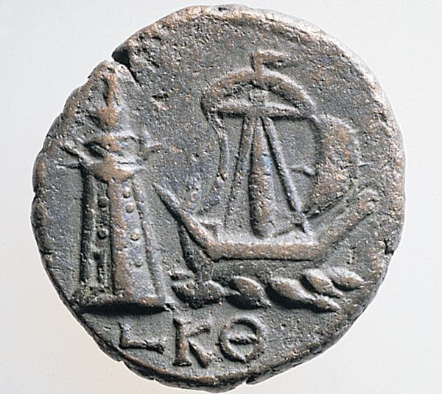

17. Looking at the image of the Roman coin, what does it suggest about the connection between coinage, shipping, and long-distance trade during the classical era?

Your answer should include the following:
• The image of the Roman coin depicts a merchant ship near the lighthouse at Alexandria, which became
a major port city during the Hellenistic era and beyond.
• It also suggests that the Romans had developed standardized coinage systems that were in use across
the Mediterranean world and beyond.
• These coins provided stable and measurable rates of exchange for goods and commodities that came
from across the eastern hemisphere.
• The depiction of the ship indicates the importance of maritime technology for classical long-distance
trade.
• Ships like this one sailed throughout the Indian and Mediterranean trade basins, carrying cargoes in all
directions.

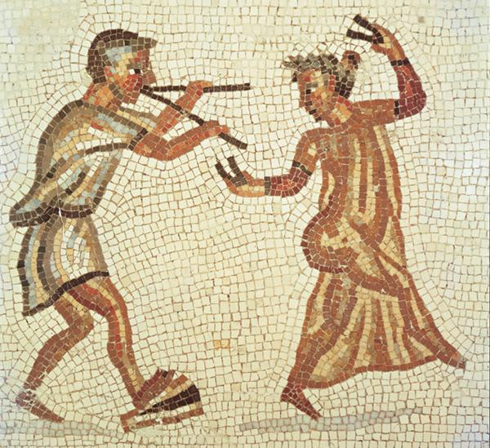
18. Using the image of the musician and dancer, and referring to the text, discuss the importance of silk as a long-distance trade commodity

Your answer should include the following:
• Silk imported from China became a major luxury trade commodity in the Roman empire.
• Roman elites consumed large quantities of silk, both as fashion garments and also to clothe their slaves
and entertainers, as the image of the silk-robed dancer demonstrates.
• Some Roman merchants even stretched their silk supplies by unraveling the densely woven Chinese
fabrics and reweaving them into larger numbers of sheer garments.
• These see-through silk garments led some Romans to complain that these items would lead to moral
decay.

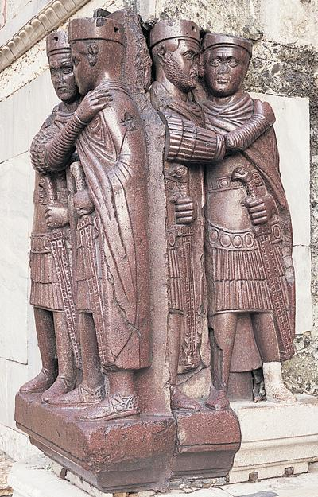

19. Look at the image above. What historical event does it depict?
Your answer should include the following:
• The image is a sculpture of the tetrarchs, or four co-rulers of the Roman empire during the later third century C.E.
• This occurred during the rule of the emperor Diocletian.
• The four co-rulers were Galerius, Constantius, Diocletian, and Maximian.

20. Use the image and the text to discuss the reasons behind the emperor Diocletian's decision to divide up the Roman empire.
Your answer should include the following:
• In the late third century C.E., the Roman emperor Diocletian divided up the Roman empire into two
administrative districts in the east and west.
• Under Diocletian's new structure, a co-emperor ruled each district with the aid of a powerful lieutenant.
• Diocletian did this in an attempt to make ruling the sprawling Roman empire more manageable, and to
improve the efficiency of imperial administration.
• However, his reforms also encouraged ambition among the four co-rulers, and after his retirement in 305 C.E. a round of struggles and bitter civil wars began.

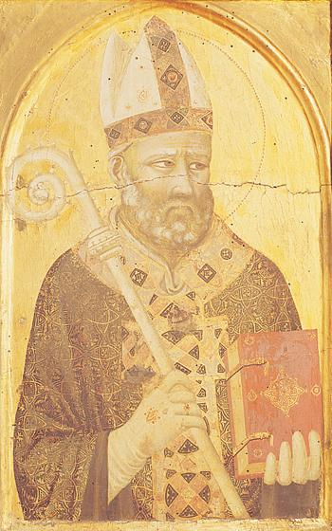

21. Using the image and the text, explain who St. Augustine was and discuss his contribution to the development of Christianity in the later Roman empire.

Your answer should include the following:
• St. Augustine (354-430 C.E.) was bishop of Hippo in north Africa.
• He converted to Christianity in 387 C.E.
• For much of his life, he worked to reconcile Christianity with Greek and Roman philosophical traditions,
particularly Platonism.
• St. Augustine's writings were more influential than any other factor in making Christianity an
intellectually respectable belief system.

22. Look at the image of St. Augustine, and identify features of the image that represent him as deeply pious.

Your answer should include the following:
• The image shows St. Augustine holding a copy of his most famous work, The City of God, which sought
to explain the meaning of history from a Christian perspective.
• He is dressed in his church robes, and is carrying his staff as a symbol of his office.
• His eyes are focused upward, toward the heavens, as another sign of his piety.

